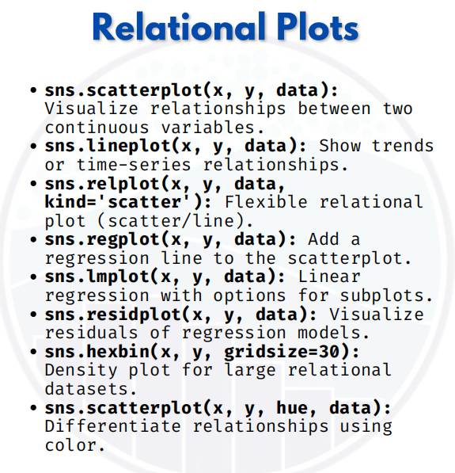

Relational plot

import seaborn as sns
import matplotlib.pyplot as plt
import pandas as pd

# Sample dataset
data = pd.DataFrame({
"Hours_Studied": [1, 2, 3, 4, 5, 6, 7, 8, 9, 10],
"Scores": [35, 40, 50, 55, 60, 65, 70, 78, 85, 95],
"Student": ["A","B","C","D","E","F","G","H","I","J"]
})

1. Scatterplot
sns.scatterplot(x="Hours_Studied", y="Scores", data=data)
plt.show()
Shows relationship between study hours & scores.

2. Lineplot
sns.lineplot(x="Hours_Studied", y="Scores", data=data)
plt.show()
Shows trend (increasing score with more study hours).

3. Relplot (Scatter)
sns.relplot(x="Hours_Studied", y="Scores", data=data, kind="scatter")
plt.show()
Same as scatterplot but more flexible (e.g., easy faceting).

4. Regplot
sns.regplot(x="Hours_Studied", y="Scores", data=data)
plt.show()
Scatterplot with a regression line.

5. Lmplot
sns.lmplot(x="Hours_Studied", y="Scores", data=data)
plt.show()
Similar to regplot but can easily make subplots by category.

6. Residplot
sns.residplot(x="Hours_Studied", y="Scores", data=data)
plt.show()
Shows residuals (differences from regression line).

7. Hexbin Plot
plt.hexbin(data["Hours_Studied"], data["Scores"], gridsize=5, cmap="Blues")
plt.colorbar(label="count")
plt.show()
Useful when lots of data points overlap.

8. Scatterplot with Hue
sns.scatterplot(x="Hours_Studied", y="Scores", hue="Student", data=data)
plt.show()
Differentiates points by student (color).

